**Solution Approach:**

**Assumption made for following data:**

Metadata –

•        Time difference between ‘start_at’ and ‘end_at’ is 1 day. ‘start_at’ date is random and time is 22:00:00.

•        All the activities are created within the interval ‘start_at’ & ‘end_at’ dates.

Ticket/Activity –

•        A “ticket_id” can have multiple activities. Each activity data can have a note, activity details or both. “Activites_count” gets updated based on the number of activities present.

•        Below is the example of the same ticket but having different activities

|  |  |
| --- | --- |
| Activity 1 | Activity 2 |
| {      "performed_at": "2017-04-27 21:10:25.143346",  **"ticket_id": 17,**      "performer_type": "engineer",      "performer_id": 121946,      "activity": {          "note": {              "id": 34325530,              "type": 2          },          "shipping_address": "2/A st",          "shipment_date": "2017-05-02",          "category": "Phone",          "contacted_customer": "true",          "issue_type": "Incident",          "source": 1,  **"status": "Open",**          "priority": 1,          "group": "refund",          "agent_id": 53187,          "requester": 23009,          "product": "Ipad"      }  } | {      "performed_at": "2017-04-28 14:54:20.065340",  **"ticket_id": 17,**      "performer_type": "engineer",      "performer_id": 486224,      "activity": {          "note": {              "id": 95887798,              "type": 2          },          "shipping_address": "2/A st",          "shipment_date": "2017-05-02",          "category": "Phone",          "contacted_customer": "true",          "issue_type": "Incident",          "source": 1,  **"status": "Resolved",**          "priority": 1,          "group": "refund",          "agent_id": 53187,          "requester": 23009,          "product": "Ipad"      }  } |

|  |  |
| --- | --- |
| **JSON format** | **Comments** |
| "performed_at": "2017-04-27 21:10:25.143346" | Timestamp linked to the status change for a ticket. This attribute will be used to calculate Time spent under particular status. |
| **"**ticket_id": 17 | JSON program will generate various tickets using user entered ticket count. A ticket can have multiple activities linked to the same ticket id. |
| "performer_type": "engineer",      "performer_id": 121946 | A ticket can have different details for these fields based on activity. |
| "activity": {          "note": {              "id": 61452798,              "type": 4          }, | An activity may have these details. The program randomly makes a decision of whether to populate these details are not. |
| "shipping_address": "56/T st",          "shipment_date": "2010-01-07",          "category": "Tablet",          "contacted_customer": "false",          "issue_type": "workrequest",          "source": 1,          "status": "Waiting for Customer",          "priority": 1,          "group": "replacement",          "agent_id": 54822,          "requester": 73756,          "product": "Ipad" | An activity may have these details. The program randomly makes a decision of whether to populate these details are not. |
| "shipping_address": "56/T st",          "shipment_date": "2010-01-07",          "category": "Tablet",          "contacted_customer": "false",          "issue_type": "workrequest",          "source": 1,          "priority": 1,          "group": "replacement",          "agent_id": 54822,          "requester": 73756,          "product": "Ipad" | If these details are populated for a ticket, then they will remain the same for all activities across the ticket. These details are randomly generated. |
| "status": "Waiting for Customer", | A ticket can have different statuses. “Performed_at” attribute will be set as per the status. |

I have used the following logic for calculating the following attributes:

•        **Time spent Open**: time difference for activity status change from ‘open’ to ‘waiting for customer’

•        **Time spent Waiting on Customer**: time difference for activity status change from  ‘waiting for customer’ to ‘Waiting for Third party’

•        **Time spent waiting for response (Pending Status):** time difference for activity status change from ‘open’ to ‘waiting for customer’

•        **Time till resolution**: time difference for activity status change from ‘open’ to ‘waiting for customer’

•        **Time to first response**: time difference for activity status change from ‘open’ to ‘waiting for customer’

**Database Schema**

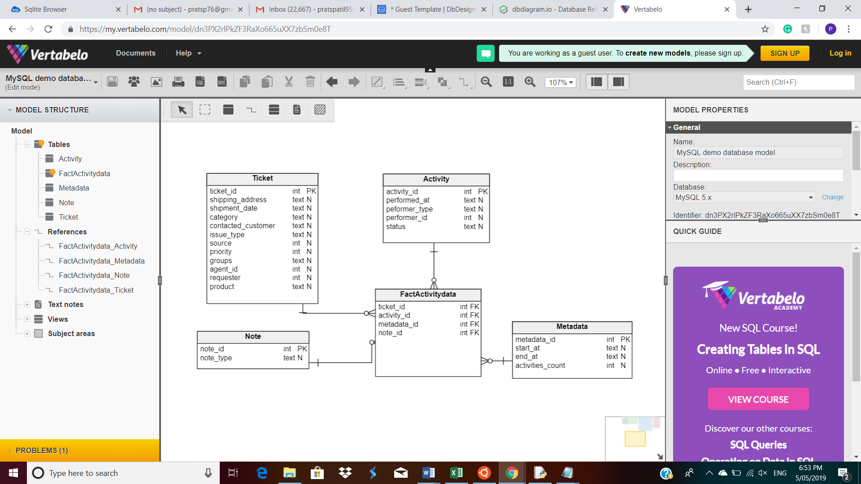

**Appendix:**

How to run:

**Bashscript**:

#!/user/bin/bash

python3 ticket_gen.py 1000 act.json;

*(takes 2 arguments, ticket count and output json file name )*

python3 jsontodb.py act.json activity.db;

*(takes 2 arguments, input json file generated by ticket_gen.py and database name)*

sqlite3 activity.db ".read sqlscript.sql"

*(takes argument database generated by jsontodb.py and sql query)*

**Output screenshot –**

